S.V.C.R.GOVERNMENT DEGREE COLLEGE PALAMANER.
DEPARTMENT OF ECONOMICS

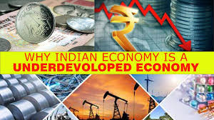
CLASS SEMINAR RECORD

S.V.C.R. GOVERNMENT DEGREE COLLEGE, PALAMANER.
DEPARTMENT OF ECONOMICS
CLASS SEMINAR

NAME OF THE STUDENT : N. LOKESH
CLASS : II B.A (HEP)
TOPIC : S.D

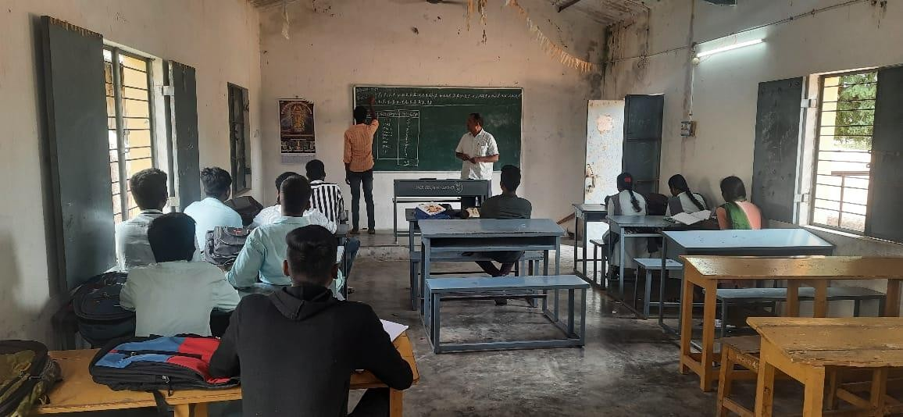

SIGNATURE OF THE STUDENT SIGNATURE OF THE LECTURER

S.V.C.R. GOVERNMENT DEGREE COLLEGE, PALAMANER.
DEPARTMENT OF ECONOMICS
CLASS SEMINAR

NAME OF THE STUDENT : A. BABU
CLASS : I B.A
TOPIC : Differences Between Micro Economics and
Macro Economics
DATE :

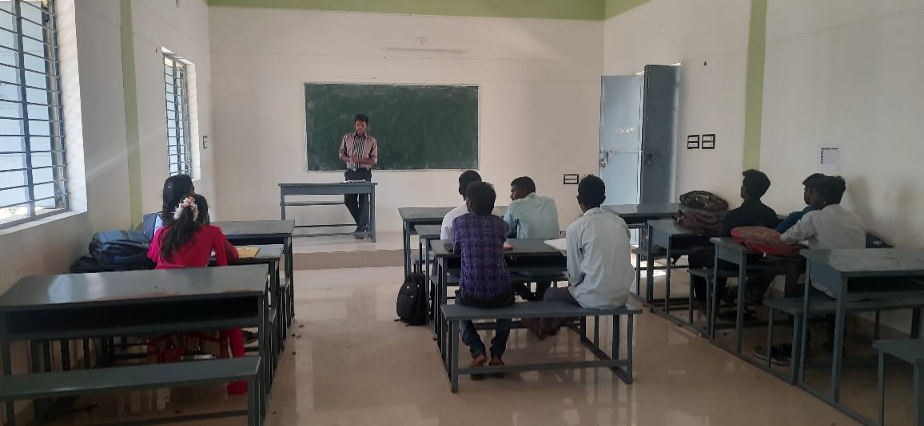

SIGNATURE OF THE STUDENT SIGNATURE OF THE LECTURER

S.V.C.R. GOVERNMENT DEGREE COLLEGE, PALAMANER.
DEPARTMENT OF ECONOMICS
CLASS SEMINAR

NAME OF THE STUDENT : T. SESHADRI
CLASS : I B.A
TOPIC : Law of Variable Proportions

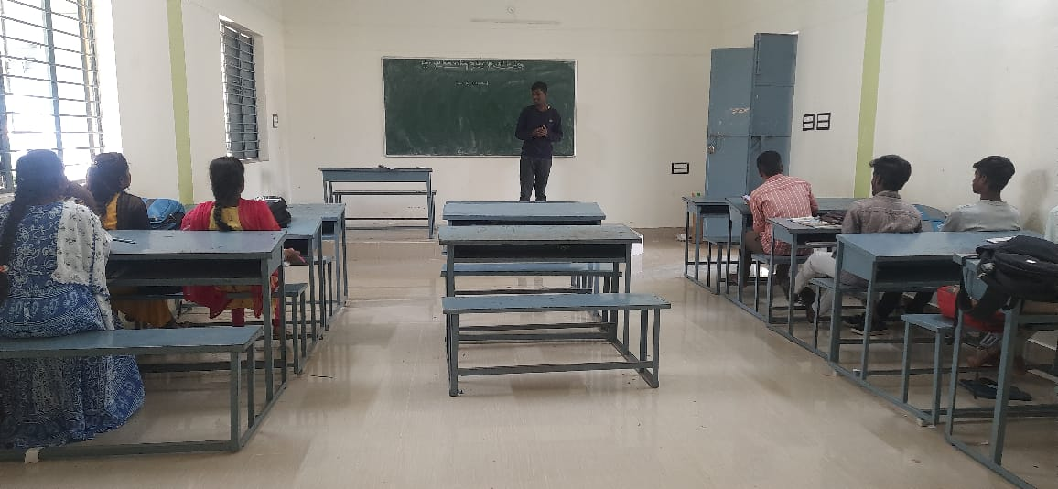

SIGNATURE OF THE STUDENT SIGNATURE OF THE LECTURER

S.V.C.R. GOVERNMENT DEGREE COLLEGE, PALAMANER.
DEPARTMENT OF ECONOMICS
CLASS SEMINAR

NAME OF THE STUDENT : M. HINDUMATHI
CLASS : II B.A(HEP)
TOPIC : Growth Model of W.W.Rostow

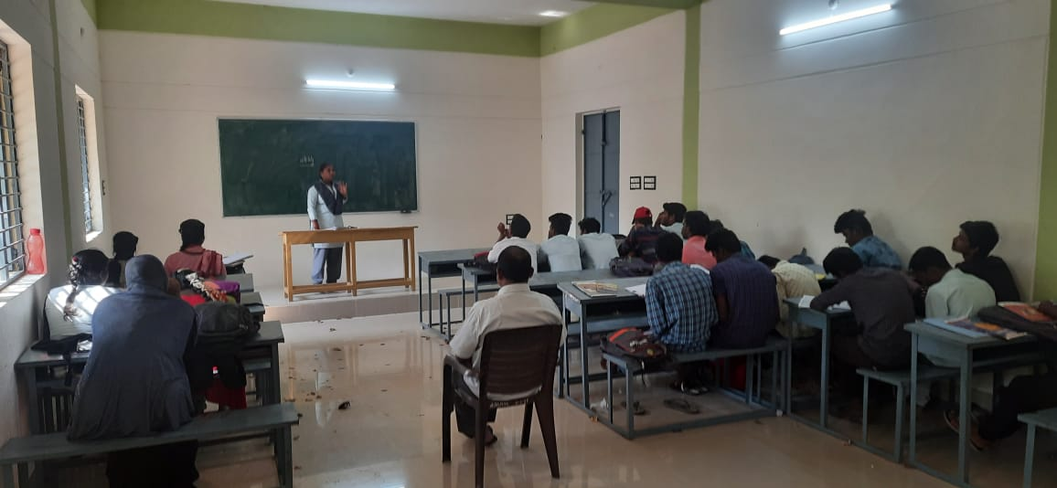

SIGNATURE OF THE STUDENT SIGNATURE OF THE LECTURER

S.V.C.R. GOVERNMENT DEGREE COLLEGE, PALAMANER.
DEPARTMENT OF ECONOMICS
CLASS SEMINAR

NAME OF THE STUDENT : T. JAYANTHI
CLASS : III B.A (HEP)
TOPIC : Features of LIC

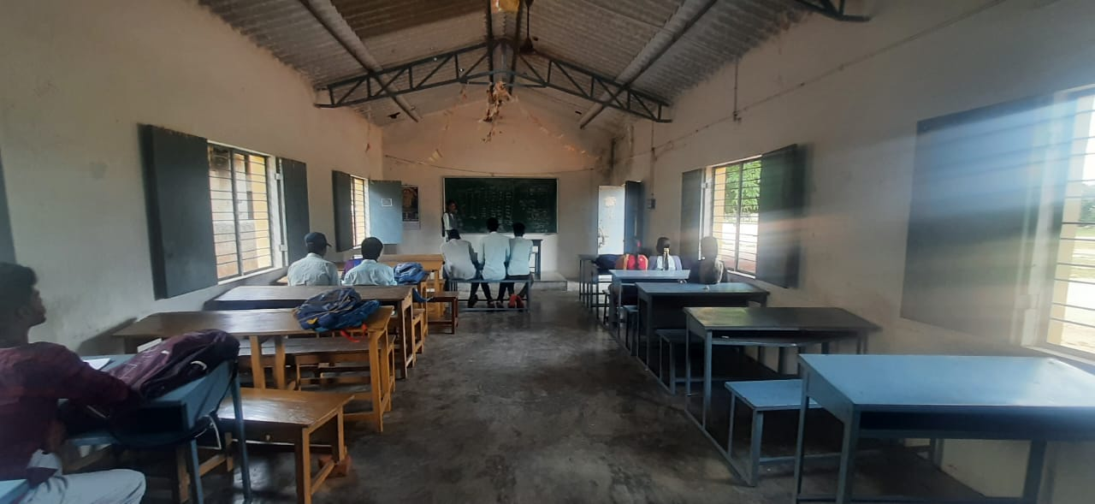

SIGNATURE OF THE STUDENT SIGNATURE OF THE LECTURER

S.V.C.R. GOVERNMENT DEGREE COLLEGE, PALAMANER.
DEPARTMENT OF ECONOMICS
CLASS SEMINAR

NAME OF THE STUDENT : A. SIVARAM
CLASS : III B.A (HEP)
TOPIC : Functions of RBI

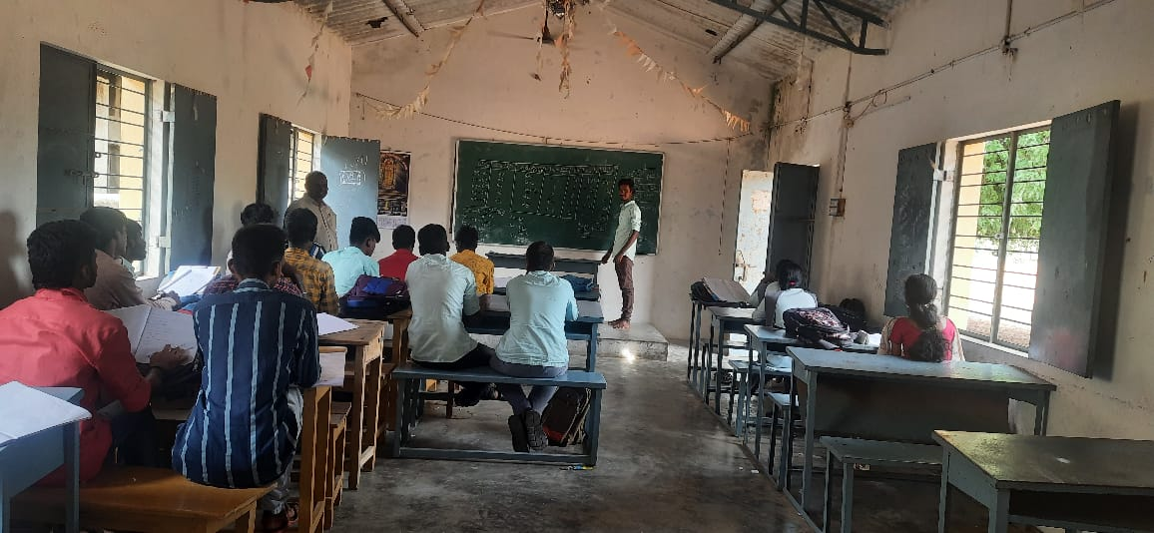

SIGNATURE OF THE STUDENT SIGNATURE OF THE LECTURER

S.V.C.R. GOVERNMENT DEGREE COLLEGE, PALAMANER.
DEPARTMENT OF ECONOMICS
CLASS SEMINAR

NAME OF THE STUDENT : D. SUFFIYA
CLASS : II B.A ( HEP )
TOPIC : Features of Developing Countries

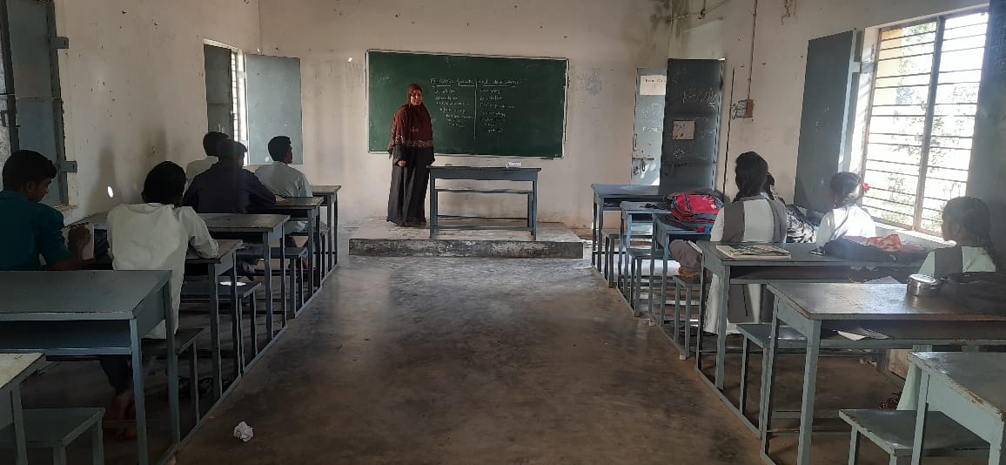

SIGNATURE OF THE STUDENT SIGNATURE OF THE LECTURER

S.V.C.R. GOVERNMENT DEGREE COLLEGE, PALAMANER.
DEPARTMENT OFECONOMICS
CLASS SEMINAR

NAME OF THE STUDENT : MAHESWARI
CLASS : II B.A (HEP)
TOPIC : Causes and Remedial measures Unemployment
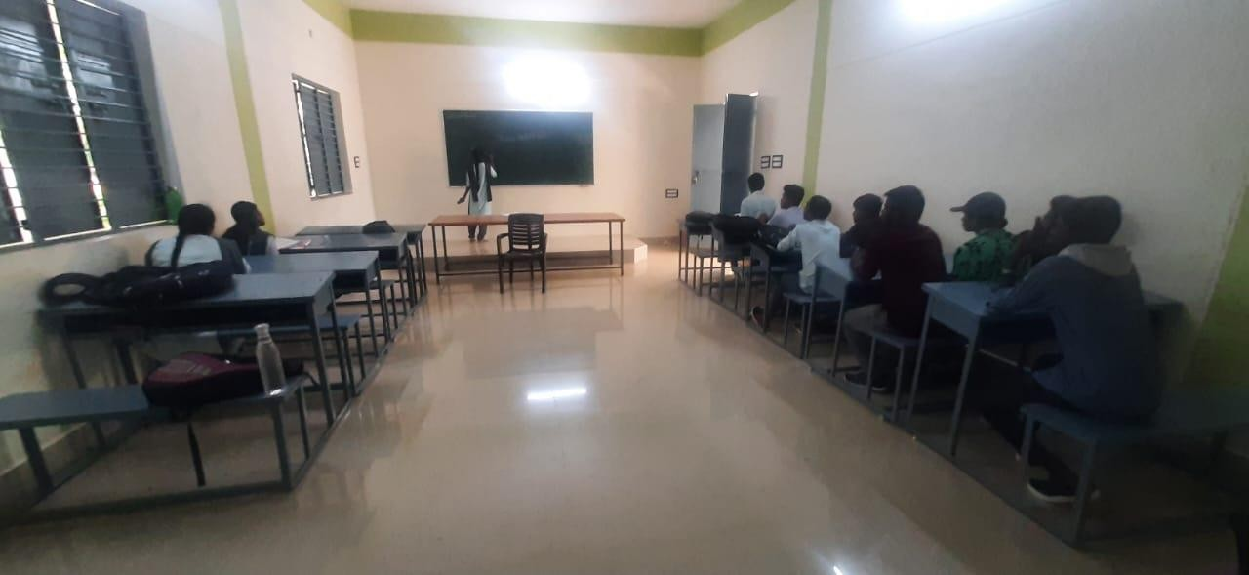

SIGNATURE OF THE STUDENT SIGNATURE OF THE LECTURER

